**GoMikeDesigns Optimization report**

# Summary

1. **- Due diligence – Detection of significant** **problems**

1. **- Keyword research**

1. **- Site optimization**

1. **– Reporting**

## 1 – Due diligence – Detection of significant problems

As a first step, a quick analysis of the site and the associated code gives the following results:

* Meta tags are irrelevant.
* It appears that the site is not responsive due to the images.
* There is content that is not visible on the site ie the nav section in the contact page ( there is a > left on the link to page 2 )
* The index and page2 pages do not have a description.
* The images are too heavy and some are wrong .
* The language attribute of the page is not specified.

In a second step, the lighthouse and wave audit tools made it possible to analyze the site and detect seo, accessibility, performance and best practice problems for us to make changes so that the page can be found much easily.

**Lighthouse results:**

**Version Desktop before**

Page index.html

Page2.html

**Version mobile**

Page index.html

Page2.html

This shows that Performance, accessibility, best practices and SEO needs to be improved.

**Wave results, highlighting accessibility issues:**

Page index.html Page2.html

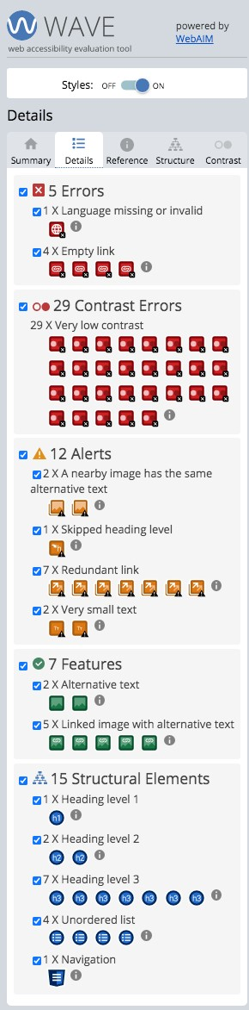

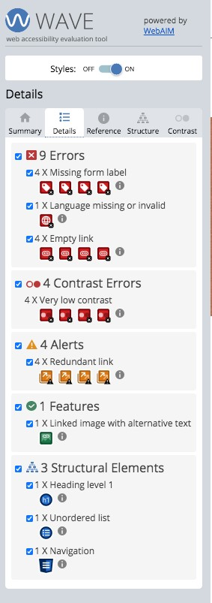

Before after

## 3 - Site optimization

***In the HEAD***  ***section***

Adding meta description on the 2 pages (seo)

1. Adding a title for the 2 pages (seo)
2. Removing the metakeywords tag (seo) as google have discontinued this service
3. Positioning of tags <script> at the end of the document (best practice) 6. Applying the right paths to the style sheets on page 2 (seo)

7. Renaming page 2 to contact.html (seo)

Old index page:

New index page:

Old page 2/contact

New page 2/contact